***1)Flow chart to check whether the number is a palindrome or not.***

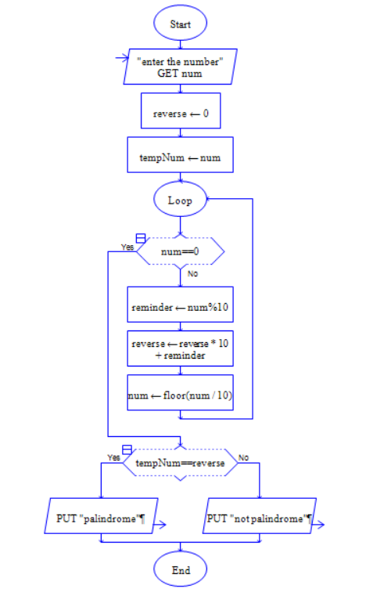

**Flow Chart to calculate Fabonaccai Series**

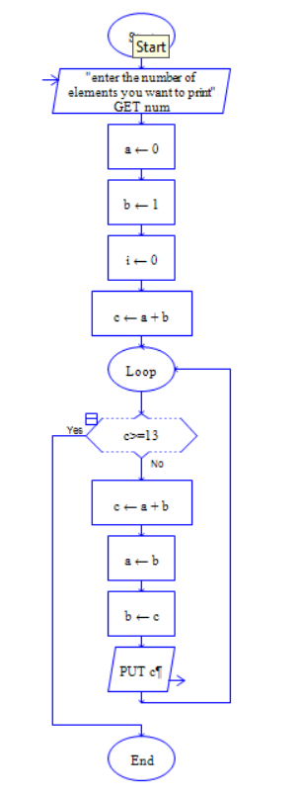

**Flow chart to check whether the number is even or odd**

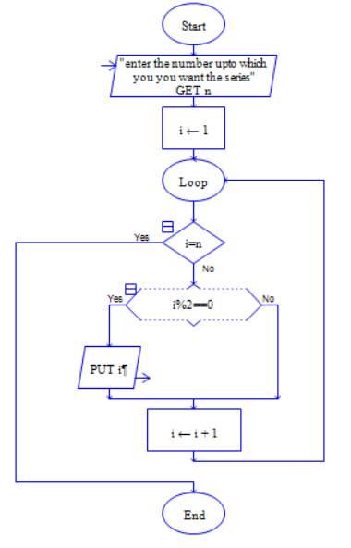

**Flow chart to find the factorial of a number**

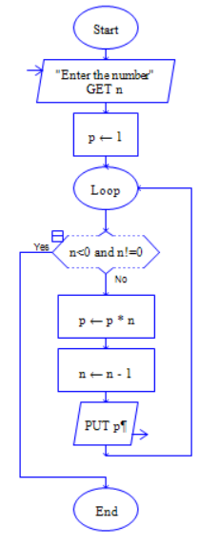

***Flow chart to find the length of a string***

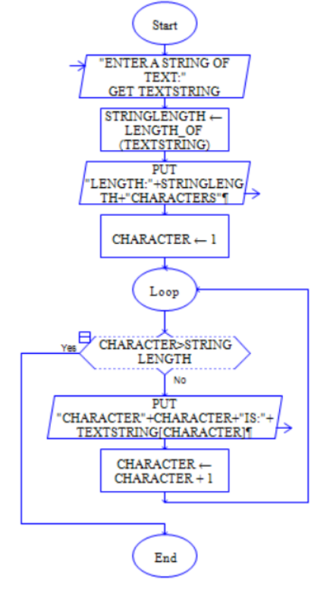

***Flow chart to find the Swap of two numbers***

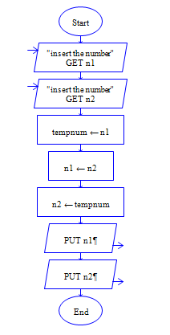

***Flow chart to find whether the number is Prime or not***

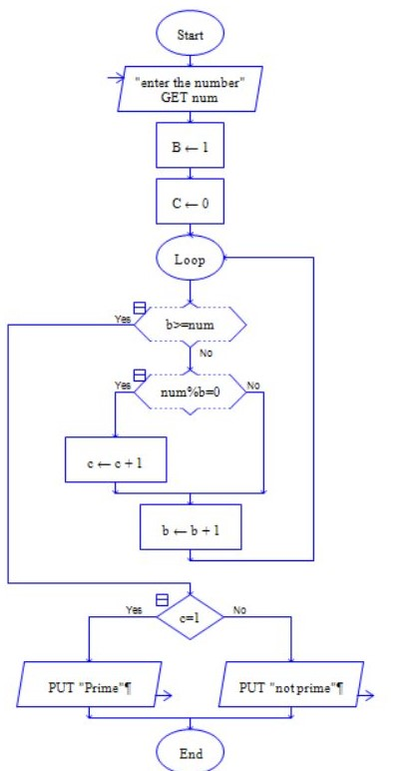

***Flow chart to find the number is Even or odd***

